**DAY-04:**

1.CODE

# Input vector of height

height <- c(151, 174, 138, 186, 128, 136, 179, 163, 152, 131)

# Input vector of weight

weight <- c(63, 81, 56, 91, 47, 57, 76, 72, 62, 48)

# Create a data frame using the height and weight vectors

data <- data.frame(height, weight)

# Fit a linear regression model to the data

model <- lm(weight ~ height, data = data)

# Predict the weight of a person with height 170

predicted_weight <- predict(model, data.frame(height = 170))

# Print the predicted weight

cat("Predicted weight for height 170 cm:", round(predicted_weight, 2), "kg\n")

# Generate a scatter plot of the data with the regression line

plot(weight ~ height, data = data, main = "Height vs. Weight", xlab = "Height (cm)", ylab = "Weight (kg)")

abline(model, col = "red")

0utput:

weight for height 170 cm: 76.23 kg

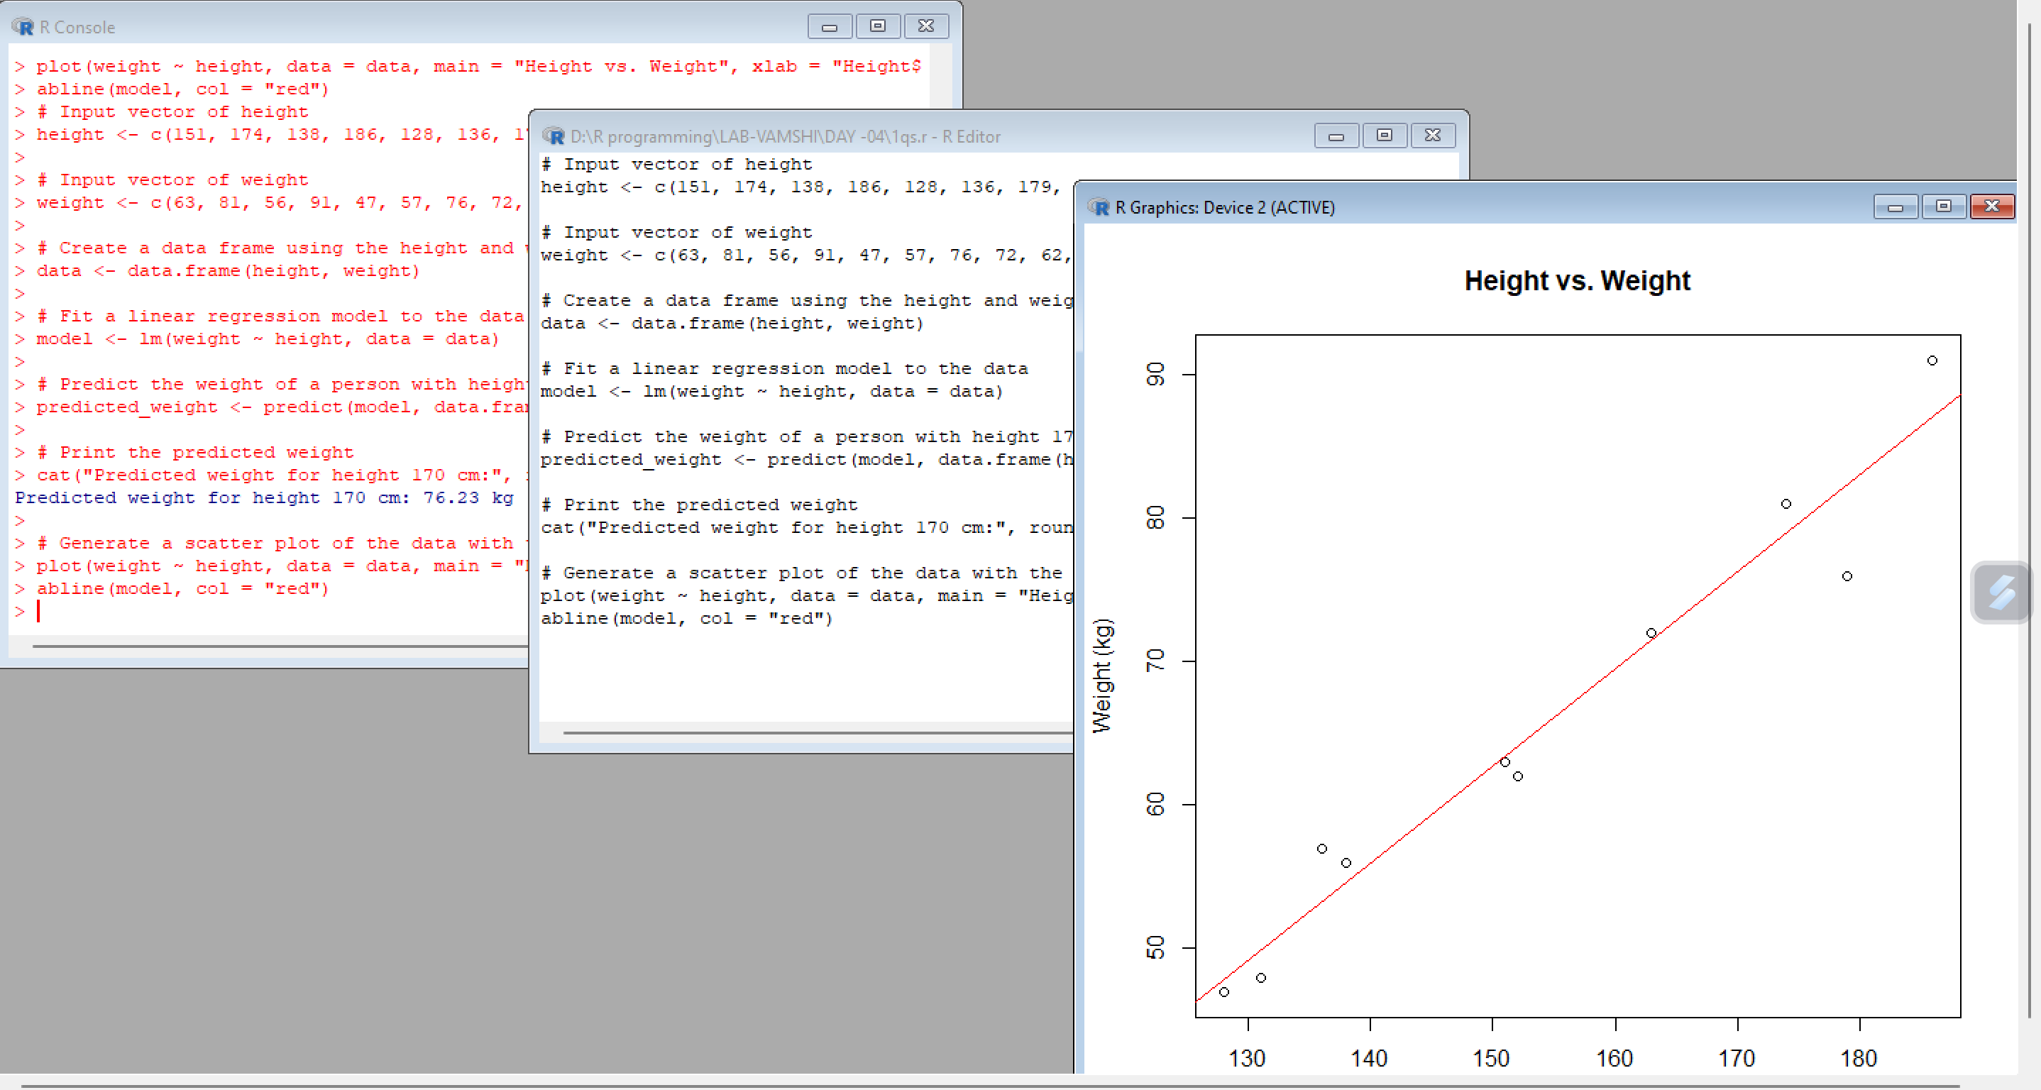

2.code

library(ggplot2)

library(dplyr)

library(dslabs)

data(water)

str(water)

ggplot(water, aes(x = hardness, y = mortality)) +

geom_point() +

xlab("Water Hardness") +

ylab("Mortality Rate")

model <- lm(mortality ~ hardness, data = water)

summary(model)

newdata <- data.frame(hardness = 88)

prediction <- predict(model, newdata = newdata)

prediction

output:

Residuals:

Min 1Q Median 3Q Max

-6.3002 -1.6629 0.0412 1.8944 3.9775

Coefficients:

Estimate Std. Error t value Pr(>|t|)

(Intercept) -38.45509 8.04901 -4.778 0.00139 **

height 0.67461 0.05191 12.997 1.16e-06 ***

---

Signif. codes: 0 ‘***’ 0.001 ‘**’ 0.01 ‘*’ 0.05 ‘.’ 0.1 ‘ ’ 1

Residual standard error: 3.253 on 8 degrees of freedom

Multiple R-squared: 0.9548, Adjusted R-squared: 0.9491

F-statistic: 168.9 on 1 and 8 DF, p-value: 1.164e-06

> newdata <- data.frame(hardness = 88)

> prediction <- predict(model, newdata = newdata)

Warning message:

'newdata' had 1 row but variables found have 10 rows

> prediction

1 2 3 4 5 6 7 8

63.41109 78.92713 54.64115 87.02246 47.89505 53.29193 82.30018 71.50642

9 10

64.08570 49.91888

>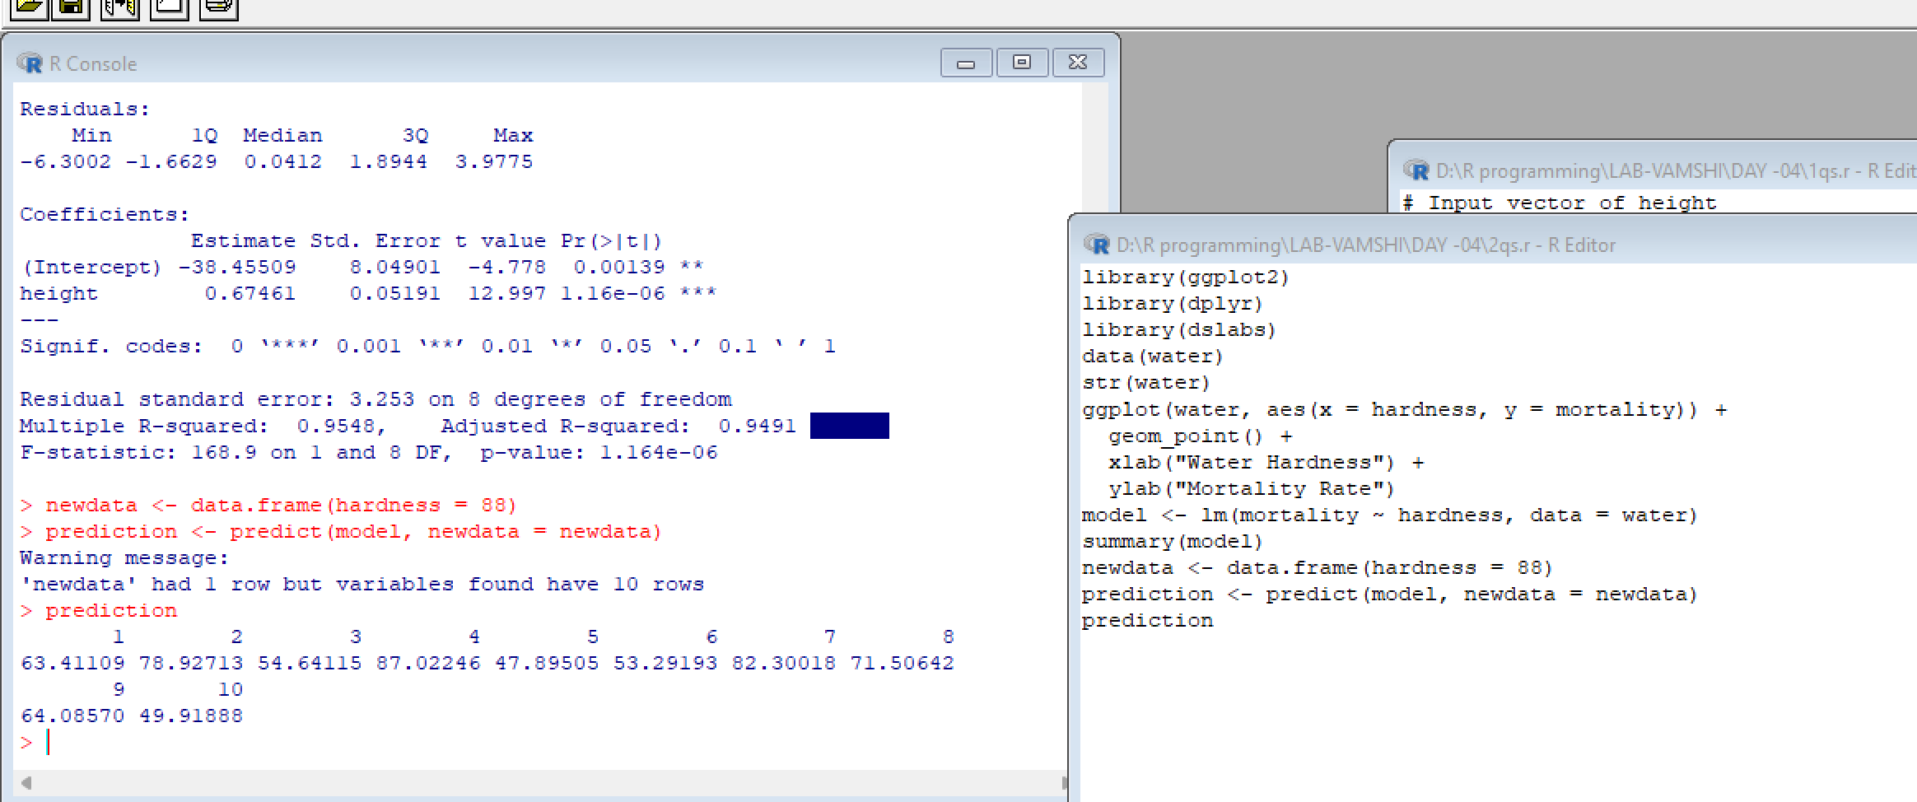

3.code

# Load the mtcars dataset

data(mtcars)

# Fit a multiple regression model with mpg as the response variable and disp, hp, and wt as predictor variables

model <- lm(mpg ~ disp + hp + wt, data = mtcars)

# Print the model summary

summary(model)

# Predict the mileage of a car with disp = 221, hp = 102, and wt = 2.91

newdata <- data.frame(disp = 221, hp = 102, wt = 2.91)

prediction <- predict(model, newdata = newdata)

prediction

output

Call:

lm(formula = mpg ~ disp + hp + wt, data = mtcars)

Residuals:

Min 1Q Median 3Q Max

-3.891 -1.640 -0.172 1.061 5.861

Coefficients:

Estimate Std. Error t value Pr(>|t|)

(Intercept) 37.105505 2.110815 17.579 < 2e-16 ***

disp -0.000937 0.010350 -0.091 0.92851

hp -0.031157 0.011436 -2.724 0.01097 *

wt -3.800891 1.066191 -3.565 0.00133 **

---

Signif. codes: 0 ‘***’ 0.001 ‘**’ 0.01 ‘*’ 0.05 ‘.’ 0.1 ‘ ’ 1

Residual standard error: 2.639 on 28 degrees of freedom

Multiple R-squared: 0.8268, Adjusted R-squared: 0.8083

F-statistic: 44.57 on 3 and 28 DF, p-value: 8.65e-11

>

> # Predict the mileage of a car with disp = 221, hp = 102, and wt = 2.91

> newdata <- data.frame(disp = 221, hp = 102, wt = 2.91)

> prediction <- predict(model, newdata = newdata)

> prediction

1

22.65987

>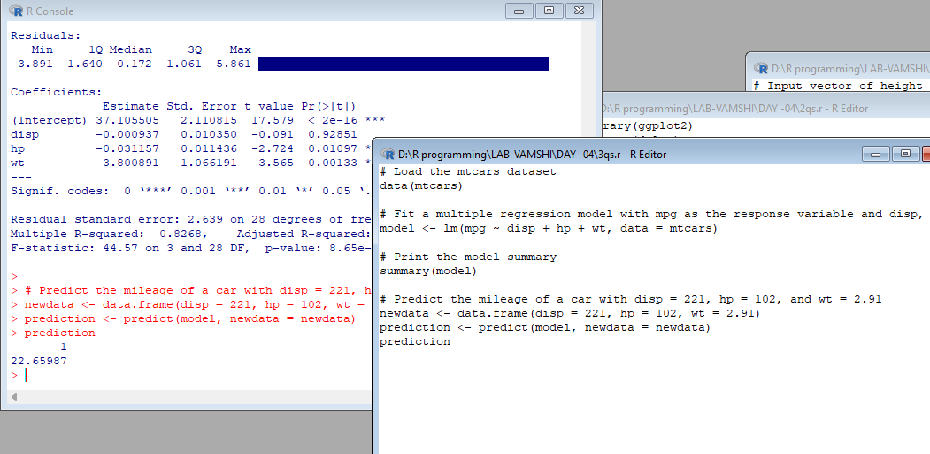

Code-04

# Load the "delivery" dataset

data(delivery)

# Create a linear regression model

model <- lm(delTime ~ n.prod + distance, data = delivery)

# Print the summary of the model

summary(model)

# Predict delTime for n.prod = 9 and distance = 450

newdata <- data.frame(n.prod = 9, distance = 450)

prediction <- predict(model, newdata = newdata)

# Print the predicted delTime

Prediction

Output:

> # Load the "delivery" dataset

> data(delivery)

Warning message:

In data(delivery) : data set ‘delivery’ not found

>

> # Create a linear regression model

> model <- lm(delTime ~ n.prod + distance, data = delivery)

Error in is.data.frame(data) : object 'delivery' not found

>

> # Print the summary of the model

> summary(model)

Call:

lm(formula = mpg ~ disp + hp + wt, data = mtcars)

Residuals:

Min 1Q Median 3Q Max

-3.891 -1.640 -0.172 1.061 5.861

Coefficients:

Estimate Std. Error t value Pr(>|t|)

(Intercept) 37.105505 2.110815 17.579 < 2e-16 ***

disp -0.000937 0.010350 -0.091 0.92851

hp -0.031157 0.011436 -2.724 0.01097 *

wt -3.800891 1.066191 -3.565 0.00133 **

---

Signif. codes: 0 ‘***’ 0.001 ‘**’ 0.01 ‘*’ 0.05 ‘.’ 0.1 ‘ ’ 1

Residual standard error: 2.639 on 28 degrees of freedom

Multiple R-squared: 0.8268, Adjusted R-squared: 0.8083

F-statistic: 44.57 on 3 and 28 DF, p-value: 8.65e-11

>

> # Predict delTime for n.prod = 9 and distance = 450

> newdata <- data.frame(n.prod = 9, distance = 450)

> prediction <- predict(model, newdata = newdata)

Error in eval(predvars, data, env) : object 'disp' not found

>

> # Print the predicted delTime

> prediction

1

22.65987

